**About ASK Technology:-**

ASK Technology incorporated in 2004 as an entity promoted by well-qualified engineers, computer professionals and businessmen specialized in **IT Enabled Services, ERP Solution, Material Management Software,**

**Order Management Software, Asset Management, HR & Payroll**

**Solution with Attendance Reader interface and Exclusive ERP for apparel Manufacturing industries,** who bring with them several years of business and professional experience. This rich experience of promoters in various industries helps the organization assimilate customer requirement at a faster pace.

**The Company Believes:-**

*"Perfection through innovation"*

*“Set the constant innovation as our key for achieving the ultimate goal of success and emerge as a global company by providing the superior quality services and solutions."*

In the global business arena, the world has been divided into small platforms in order to deliver the market requisites in no time. The rapid growth and mind-boggling pace of changes in the technology has compelled the business world to integrate for the latest technology amendments.

The changing face of technology has rendered a different dimension to the vision of management gurus in the business world. Amalgamation of new concepts and techniques with business has become an advanced mantra for the business realm.

**ASK Technology** routinely meets myriad challenges in the technology arena and synchronizes solutions to meet the changing faces of the business world. We help you adhere to your strict schedules and deadlines and thereby serve your customer better.

**Our value proposition: -***delivering on-time, premier quality, best cost services*

**Our Motto**

*"Excellence in customer's need based solutions and services"*

We strive to deliver outstanding quality of work through a dedicated team of professionals using Innovative Ideas and Flexible working methods. We always keep in mind, the trust and mutual respect required by our clients in all aspects of our business and ensures the same by our high levels of integrity.

**TOMS–V3.0 Functional Module Detail**

|  |  |
| --- | --- |
| Sales | **Purchase** |
|  |  |
| **Inventory** | **Finance** |
|  |  |
| **Features** | |
|  | |
|  | |
|  | |

**TOMS Special Features :**

1. **Auto-generated Email Alerts To Collect Payments :** An auto-generated email with maximum of 4 times a month, with complete Statement of Account can be sent to customers whose payment is pending exceeding the credit days.
2. **Outstanding Payment Alert System :** Creating the Delivery Challan and Invoice, the system highlights the due amount of the customer, which may cross the credit limit of the customer. This facilitates the supplier to alert the customer on the payment and to follow up the balance payment.
3. **Avoiding Pre-Quote Mistakes :** While preparing the DC or Invoice, the system lists out the four previous billed prices of the same item. This helps quoting Correct Price.
4. **Tracking of Customers Order Performance :** System generated MIS report shows the month-wise order performance of each and every customer, on reviewing we can track and analyze the customer’s order placement, We can analyze monthly reports, whether the customer placed all the orders with us or diverted orders to other suppliers.
5. **Parameter Control and Auto-Backup of Database** etc.,

**TECHNOLOGY**

Completely Web-enabled application inbuilt with**,** technologies which allow connecting globally.

**TARGET ORDER MANAGEMENT CONSISTS OF :**

1. **Managing Your Customers**

* Easily view customer’s information and ordering preferences
* Filter customers by name, email, order number, geographic region and order date for quick reference
* Edit customer’s existing information
* View customer’s past order history
* Create new customers and save them by category
* Set custom pricing levels for groups of customers
* Export information to Excel or QuickBooks
* Maintaining customer Quotation

1. **Managing Your Orders/Sales**

* Order based delivery challan
* View order details, View tracking numbers for that order
* Add or delete an item from an order, Check the status of an order
* Issue or approve a return of the order
* Save an order as a quote
* Auto conversion of ill from Delivery challan
* Payment Receipts, Debit and credit note
* Auto alert of Credit amount based payment status while making DC and bill.

1. **Inventory Management**

* View all inventory quantities in stock, live at all times
* Set thresholds when stock levels fall below a custom set level for notification
* Place purchase orders out to vendors for replenishment by product type and quantity
* Adjust stock levels of inventory, Transfer stock from unit to order unit
* Add new products to inventory

1. **MIS Reporting**

* Day wise Order tracking and Day wise goods movement
* Pending delivery for Bills to be rise
* Daily Sales Reports, Monthly sale for customer wise
* Outstanding detail month wise and customer wise
* Over all outstanding customer wise as on date
* Monthly sales register with tax detail
* Automatic mail for customer for out standing
* Customer wise Item supplied detail
* Monthly Purchase register
* Supplier payment outstanding & Supplier Bill pending
* Statement of Account for customer and supplier bills.
* Monthly Stock item wise with value, Location wise item wise value.
* All reports can be exportable to excel and pdf. And Many more MIS….. **TOMS - ACCESS (CONNECTION) DIAGRAM.**

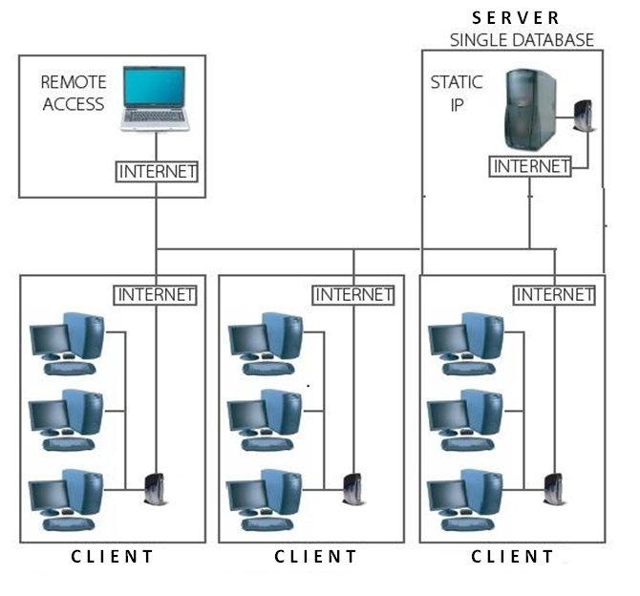

|  |  |
| --- | --- |
| TOMS – MENU CONTENT (MODULE) | |
| ADMINISTRATION | **UTILITIES** |
| 1. Parameter Control 2. User Creation 3. User Rights 4. Logoff 5. Exit | 1. Database Backup 2. Year End Process. |
| MASTERS | **TRANSACTION** |
| 1. Company Master 2. Company Branch Master 3. Product Category 4. Product Details 5. Supplier Master 6. Customer Master 7. Customer Branch Master 8. Tax (GST etc.,) 9. Unit of Measurement (UOM) 10. Terms & Conditions 11. Company Log. | 1. Customer Quotation 2. Sales Order 3. Delivery Challan 4. Sales Bill 5. Payment Receipt 6. Credit Note & Debit Note 7. Multiple Bill Printing 8. Purchase Order 9. Material Receipt 10. Bill Payment 11. DC Cancellation 12. Bill Cancellation |
| Financial Accounts | |
| Trail Balance  Profit & Loss  Balance sheet  Receivable & Payable  Cash Flow  Fund Flow | Cash Book  Bank Book  Ledger report  Day Book  Journal register  Purchase/Sales Register  Stock Ageing Analysis |
|  |  |
| CRM (Customer relationship Management )  TOMS CRM is Easy to use and customizable for your marketing, sales, and customer service teams.  Sell everything you need to increase sales and manage your team  Features of TOMS CRM   * 1. Lead creation   2. Lead follow ups   3. Lead Tracking   4. Lead status   5. Auto alert or reminder based on the schedule   6. Sales executive performance   7. Enquiry tracking   8. Auto conversion from enquiry to quotation   9. Enquiry status   TOMS CRM Benefit   * + 1. Find the best leads     2. Understand customers better     3. Boost team productivity     4. Forecast accurately     5. Engage across multiple channels     6. Minimize resolution times     7. Flexible and customizable     8. Exceptional customer support   TOMS CONNECT – Mobile Apps – [Business analyst ]   * Quick information for your day to business activity * Information Dashboard with live transaction * Quick follow ups for Customer out standing * Dial directly from mobile to customer for outstanding payment     DASH BOARD  with management information | |
| MIS REPORTS | |
| 1. List of Quotation 2. Order in Hand 3. Pending Order 4. Pending DC 5. Sales Register 6. Month-wise Sales 7. Customer-wise monthly Sales 8. Payment Status 9. Payment Outstanding Summary | 1. Payment Receipt Details 2. Payment Issue 3. Statement Of Accounts 4. Item Wise Sales Details 5. Fast Moving Item Report. 6. Item Wise Stock 7. Monthly Customer Order Status 8. Customer-wise Price List 9. Auto-mail for Outstanding. |

Feel free to call us for more detail

Thank & Regards

**Razia Sultana**

Sales executive

Sales@asktek.net .

 044-45034080

91-9840899559